**Modern Metal Kitchen Shelf**

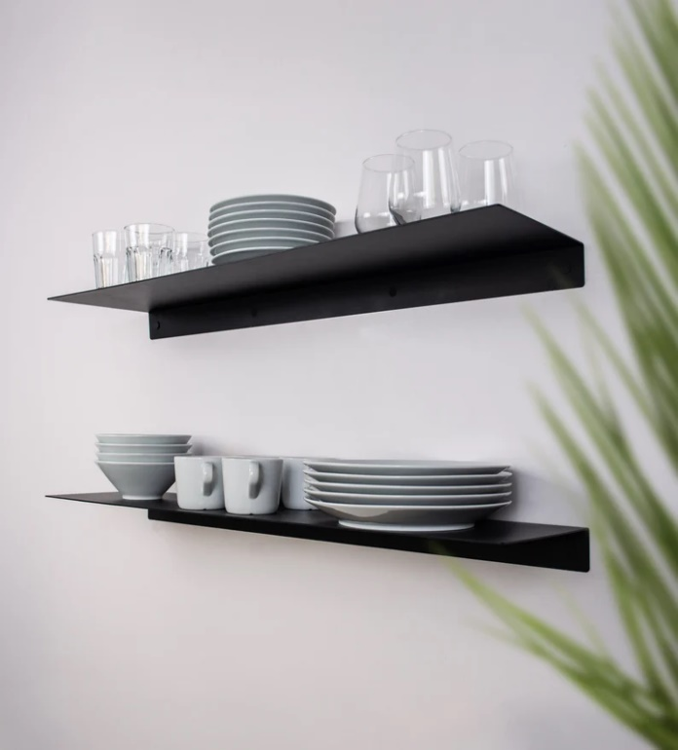A Modern Metal Kitchen Shelf combines industrial charm with practicality, making it an ideal addition to contemporary kitchens. Made from durable, high-quality metal, these shelves offer a sleek and minimalist design that complements modern kitchen décor. They provide ample space for storing and displaying kitchen essentials such as spices, utensils, pots, and decorative items, helping to keep the space organized and accessible. With options for floating shelves or shelves with brackets, modern metal kitchen shelves can be mounted on the wall to save counter space while adding a sophisticated, streamlined look to your kitchen. Whether used for storage or as a decorative feature, they bring both functionality and style to any culinary space.